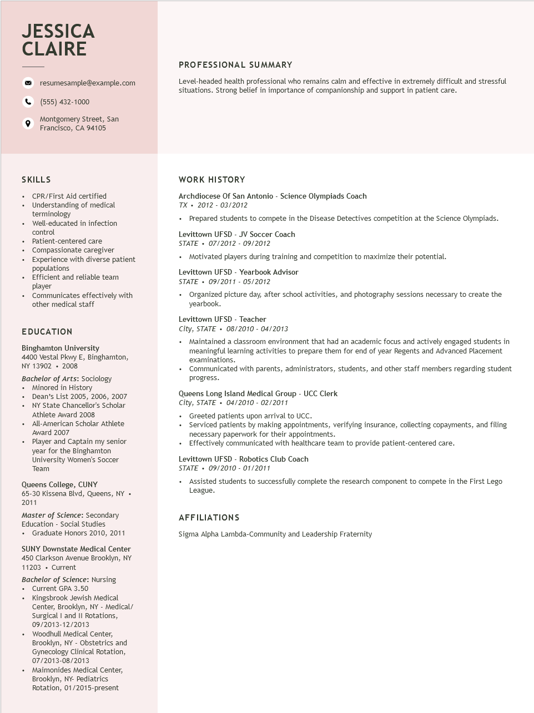
JESSICA CLAIRE
resumesample@example.com
(555) 432-1000
Montgomery Street, San Francisco, CA 94105
PROFESSIONAL SUMMARY
Level-headed health professional who remains calm and effective in extremely difficult and stressful situations. Strong belief in importance of companionship and support in patient care.
SKILLS
• CPR/First Aid certified
• Understanding of medical terminology
• Well-educated in infection control
• Patient-centered care
• Compassionate caregiver
Experience with diverse patient populations
• Efficient and reliable team player
• Communicates effectively with
other medical staff
EDUCATION
Binghamton University
4400 Vestal Pkwy E, Binghamton, NY 13902. 2008
Bachelor of Arts: Sociology • Minored in History
• Dean's List 2005, 2006, 2007
·
·
•
NY State Chancellor's Scholar
Athlete Award 2008
All-American Scholar Athlete
Award 2007
Player and Captain my senior
year for the Binghamton
University Women's Soccer Team
Queens College, CUNY
65-30 Kissena Blvd, Queens, NY. 2011
Master of Science: Secondary Education - Social Studies
• Graduate Honors 2010, 2011
SUNY Downstate Medical Center 450 Clarkson Avenue Brooklyn, NY 11203. Current
Bachelor of Science: Nursing
• Current GPA 3.50
Kingsbrook Jewish Medical
Center, Brooklyn, NY - Medical/ Surgical I and II Rotations, 09/2013-12/2013
⚫ Woodhull Medical Center, Brooklyn, NY - Obstetrics and
Gynecology Clinical Rotation, 07/2013-08/2013
Maimonides Medical Center,
Brooklyn, NY- Pediatrics
Rotation, 01/2015-present
WORK HISTORY
Archdiocese of San Antonio - Science Olympiads Coach
TX 2012-03/2012
• Prepared students to compete in the Disease Detectives competition at the Science Olympiads.
Levittown UFSD - JV Soccer Coach
STATE⚫ 07/2012 - 09/2012
• Motivated players during training and competition to maximize their potential.
Levittown UFSD - Yearbook Advisor
STATE⚫ 09/2011- 05/2012
• Organized picture day, after school activities, and photography sessions necessary to create the yearbook.
Levittown UFSD - Teacher
City, STATE 08/2010 - 04/2013
• Maintained a classroom environment that had an academic focus and actively engaged students in meaningful learning activities to prepare them for end of year Regents and Advanced Placement examinations.
• Communicated with parents, administrators, students, and other staff members regarding student progress.
Queens Long Island Medical Group - UCC Clerk
City, STATE⚫ 04/2010- 02/2011
• Greeted patients upon arrival to UCC.
• Serviced patients by making appointments, verifying insurance, collecting copayments, and filing necessary paperwork for their appointments.
• Effectively communicated with healthcare team to provide patient-centered care.
Levittown UFSD - Robotics Club Coach
STATE⚫ 09/2010 - 01/2011
• Assisted students to successfully complete the research component to compete in the First Lego League.
AFFILIATIONS
Sigma Alpha Lambda-Community and Leadership Fraternity

